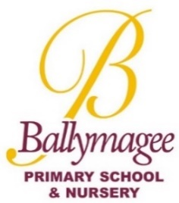

Ballymagee Newsletter

September 2026

A Message from Mr Totton
Welcome back to everyone in the Ballymagee Community! I would like to offer an especially warm welcome to our new Nursery and P1 families as well as those who have joined us throughout the school. I trust that you and your family have had an enjoyable summer break and that your child(ren) are excited about the new academic year ahead.
This year we have a new member of staff joining us as a classroom assistant. I’d like to welcome Miss Hair to the team in P2. Miss Hair is a past pupil of Ballymagee making me feel very old, as it is not so long ago that I was her teacher! It is also lovely to have Mrs Anderson back from maternity leave.

It has been great to chat with so many of you at drop off over the last few mornings. If you are not at the gate, but need to chat with me, I would encourage you to contact me through the school office.
This month we have our FAB AGM and I would encourage you to come along to this if you are available. If not, please consider signing up for our Helping Hands. More information will follow on this shortly.
With every good wish to you and your family for a blessed and successful academic year.

“Learning Today to Discover Tomorrow”
  - Key Dates
Friday 18th September
FAB AGM Meeting 1pm– everyone welcome
  - Friday 18th September
  - Registration for SEAG closes

  - Friday 25th September
  - School Development Day – School closed for all children

Tuesday 29th September
School Photographs

  - Monday 12th -Friday 16th October
  - Parent/Teacher Interviews (school will finish at 1pm for all pupils P1-P7)
Nursery will close at 12.15pm
  - Monday 26th October – Friday 30th October
  - Mid Term Holiday
Friday 20th November
Children in Need Day
Wednesday 2nd December
P1/2 Nativity 9.30am & 11am
Thursday 3rd December
P1/2 Nativity 9.30am
Monday 7th December
FAB Christmas Fair
Monday 14th December
Christmas Concert
9.30am & 11am
Thursday 16th December
Flu Vaccinations



Miss Hair

P Totton

Key Contacts
Principal Mr P Totton
Vice Principal Mr G McCrea
SENCO Mrs L Welsh
Designated Teacher Miss V Bell
Deputy Designated Teachers
Mrs L Welsh Mr G McCrea
Head of Early Years Mrs S Hanna
Head of Key Stage One Miss V Bell
Head of Key Stage Two Mrs V Purce

Find out more on our Website.
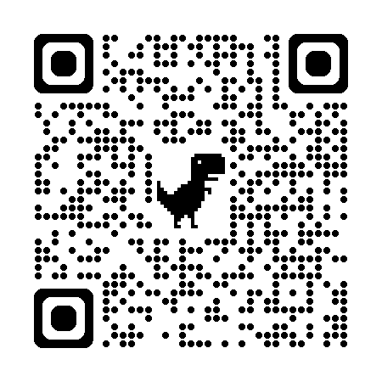
Follow us on:
Facebook
Instagram





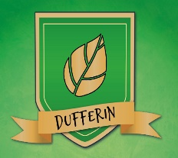


School Values

In September we will be focusing on Community. Children will be introduced to the contribution they can make to our school and the wider community by Miss Bell and Mrs Purce in assembly. They will be involved in lessons and activities throughout the month, and we will be awarding a community star pupil award.

Free School Meals/Uniform Grant
If you have not already done so, and think your child may qualify for Free School Meals, please apply via the EA Website. We would encourage all parents whose child(ren) may be eligible, to apply as soon as possible. Even if your child does not avail of the option, the school receives additional funding on the basis of numbers registered – https://www.eani.org.uk/financial-help/free-school-meals-uniform-grants




School Meals

Ballymagee is a cashless office and school meals are managed online via the downloadable app or through the website ‘School Gateway’. Families in receipt of free school meals still need to book dinners via this service, although no payment will be required.

If you haven’t already done so, please download the School Gateway app or visit the website: www.schoolgateway.com and click on ‘New User’. You’ll receive a text message with a PIN number. Use this PIN to login to School Gateway.

School meals cost £3.10, Nursey Meals cost £3.00 per day and can be booked via School Gateway from a Friday afternoon to Sunday at Midnight for the week ahead. Meals must be paid for at time of booking.

We have children in our school community with allergies. To keep them safe, it is school policy that the children do not share food. Please do not send in cakes or treats for birthday celebrations. Thank you for your cooperation.



Breakfast Club
Breakfast Club operates between 8:00am and 8:45am on days when children are in school. The cost is £3.50 per session, which includes a payment of £1.10 for breakfast. This is a fixed rate, whether breakfast is availed of or not.
Nursery children can attend Breakfast Club once they have commenced their full day. They will be brought from the school canteen to the Nursery at 8:45am.
Please use this link to book
https://supreme-sports.classforkids.io/camp/21



  - BALLYMAGEE PRIMARY SCHOOL
  - 77 Ashbury Avenue Bangor BT19 6ZG www.ballymagee.org.uk
Scooters, Bicycles, Forgotten Items
Please remember that dogs, with the exception of assistance dogs, are not permitted on the school grounds.

Children arriving to school on scooters or bicycles must wear a helmet and dismount at the school gates and push them on school grounds. Parents must push e-scooters on the school grounds also.

Please limit visits to the school office regarding dropping off forgotten items. We would greatly appreciate if you could remember to send everything with your child in the morning.
Flu Vaccine
The school nursing team will be in school on Wednesday 16th December to administer the flu vaccination to children. Forms will be sent home nearer the time. Please ensure these are returned as the vaccination will not be given without your consent.

